caXchange COPPA Integration
Prototype
Version No : Initial Draft
Last Modified : 09/05/2008

Author : Harsh Marwaha
Team : caXchange Team
Client : National Cancer Institute,
National Institutes of Health,
US Department of Health and Human Services

Document History

Document Location
The most current version of this document is located in CVS under <cvsroot>?.

Revision History
Version Number | Revision Date | Author | Summary of Changes
0.1 | 11/23/2008 | Harsh Marwaha | Initial Draft

Review
Name | Team/Role | Version | Date Reviewed | Reviewer Comments
Kalpesh Patel | Architect | 0.1

Approval
Name | Team/Role | Version | Date Reviewed | Reviewer Comments

Related Documents
More information can be found in the following related CCTS and caXchange documents:

Document Name
caXchange COPPA Integration Prototype Design.

1 Goals 5
2 Related Documentation 5
3 Description 5
4 caXchange COPPA Integration – Design 5
4.1 Component View 6
4.2 Client - caXchange Interaction 7
4.3 caXchange – COPPA Interation 8
4.4 Serialization – De-Serialization of COPPA data 9
4.5 Security 10
5 Steps for actual integration of caXchange to COPPA 10

Goals
The goal of this prototype is to investigate design approaches for integration of COPPA ejbs (enterprise java beans) with caXchange. These ejb services can then be exposed through caXchange and they are made available to CCTS suite of applications.

Related Documentation
Document | Location
caXchange Interface Specification | https://gforge.nci.nih.gov/plugins/scmcvs/cvsweb.php/caxchange/Documentation/Interface/caXchange_Interface_Specification.doc?cvsroot=caxchange
COPPA Model | http://www.ncientarch.info/coppa/logical_model/
Table 1 Related documents.

Description
This document documents the design of the prototype integration of caXchange with COPPA ejbs. This prototype was done by integrating caXchange to provide a search person service using the COPPA search person ejb.
This document also discusses alternate design approaches that should be investigated for performing this integration. It lists the steps needed to be performed for the actual integration using this design approach. Please find below a brief description of the terminologies used in this document
COPPA Ejbs – Enterprise java beans deployed as part of the COPPA application.
COPPA Ejb Client – Enterprise java bean client java archives needed to invoke COPPA ejbs.
COPPA Search Person Service – The COPPA Person Entity search person service. This is a general search person operation on the COPPA Person entity ejb.
Servicemix Bean SU – A servicemix bean service unit, which includes java beans to which caXchange messages can be routed.

caXchange COPPA Integration – Design

Component View

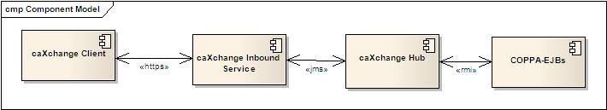
Figure 1 Component view for CCTS COPPA integration.
The figure above shows the components involved for integrating caXchange with COPPA services. It also shows the communication protocols involved between protocols.
The communication between caXchange client and the caXchange Inbound service uses the standard caXchange interface. This interface is defined in the caXchange interface specification. The caXchange client sends a caXchange request for searching persons. This request is sent over the secured https protocol to caXchange. The payload for the search person request is the serialized representation of a COPPA PersonDTO object. For the purposes of this prototype this marshalling and un-marshalling of COPPA objects was achieved using the Castor framework. This serialization and de-serialization is in addition to the RMI (Remote Method Invocation) serialization required to invoke the COPPA ejbs.
The communication between the caXchange hub software and the COPPA ejbs uses the JNDI (Java Naming and Directory Interface) and RMI communication protocols. This requires opening the non- standard communication ports to be opened between the caXchange hub software and COPPA ejbs. This can required firewall configuration to open the appropriate ports. For the purpose of this prototype the actual steps and configuration required for invoking COPPA ejbs across a firewall was not investigated. caXchange hub invoke COPPA ejbs deployed on the same machine as the hub software.
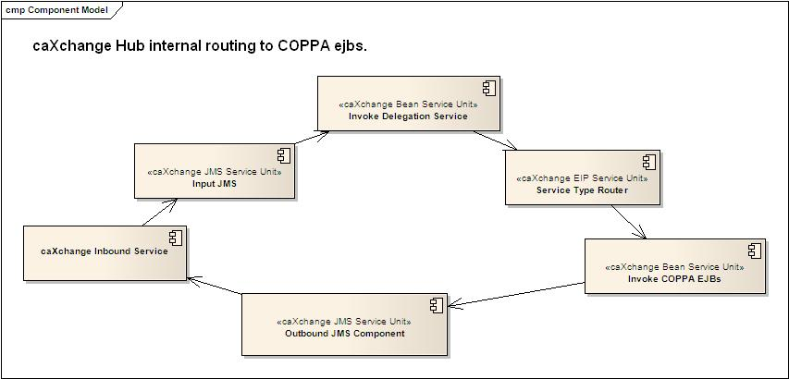
Figure 2 caXchange internal routing to COPPA ejbs.
The figure above shows the routing within the caXchange hub software for routing caXchange requests to the COPPA ejbs. This routing is similar to the routing of other caXchange services such as LAB_BASED_AE , LOAD_LAB_TO_CDMS which do not participate in transaction control. Java classes deployed as a caXchange servicemix bean service unit invoke COPPA ejbs.

Client - caXchange Interaction
There were no changes made to the caXchange interface as defined in the caXchange interface specification for this prototype. A new caXchange service type, SEARCH_PERSON was defined for integrating with COPPA search person service. Messages with the message type SEARCH_PERSON are routed to the caXchange bean service unit. The payload for these requests is the serialized PersonDTO COPPA object. This approach requires configuring a new caXchange service type for each COPPA service to be integrated. For example caXchange would need to define SEARCH_PERSON for searching persons and CREATE_PERSON for creating person objects and so on.
An alternative approach could be defining a caXchange service type for each entity such as PERSON, ORGANIZATION so on. In this case the actual COPPA operation to be invoked can be specified using the operation element in caXchange. For example this operation element can have values such as SEARCH, CREATE, DELETE so forth to define the COPPA operation to be invoked. This would require modifying caXchange interface specification to accommodate COPPA operations in the caXchange operation element.
Following is a sample caXchange request message with the business payload highlighted for this service:
<?xml version="1.0" encoding="UTF-8"?>
<ns1:caXchangeRequestMessage xmlns:ns1="http://caXchange.nci.nih.gov/messaging">
<ns1:metadata>
<ns1:operation xmlns:xsi="http://www.w3.org/2001/XMLSchema-instance" xsi:nil="true"/>
<ns1:messageType>SEARCH_PERSON</ns1:messageType>
<ns1:externalIdentifier>myExternalIdentifier</ns1:externalIdentifier>
<ns1:caXchangeIdentifier>ff727a60-8a67-11dd-9bad-f2919ce25d4f</ns1:caXchangeIdentifier>
<ns1:credentials>
<ns1:userName>ccts@nih.gov</ns1:userName>
<ns1:password>!Ccts@nih.gov1</ns1:password>
<ns1:delegatedCredentialReference>&lt;ns1:DelegatedCredentialReference xmlns:ns1="http://cds.gaards.cagrid.org/CredentialDelegationService/DelegatedCredential/types"&gt;
&lt;ns2:EndpointReference xsi:type="ns2:EndpointReferenceType" xmlns:ns2="http://schemas.xmlsoap.org/ws/2004/03/addressing" xmlns:xsi="http://www.w3.org/2001/XMLSchema-instance"&gt;
&lt;ns2:Address xsi:type="ns2:AttributedURI"&gt;https://cbvapp-d1017.nci.nih.gov:58443/wsrf/services/cagrid/DelegatedCredential&lt;/ns2:Address&gt;
&lt;ns2:ReferenceProperties xsi:type="ns2:ReferencePropertiesType"&gt;
&lt;ns2:DelegatedCredentialKey xmlns:ns2="http://cds.gaards.cagrid.org/CredentialDelegationService/DelegatedCredential"&gt;
&lt;ns3:delegationId xmlns:ns3="http://gaards.cagrid.org/cds"&gt;1516&lt;/ns3:delegationId&gt;
&lt;/ns2:DelegatedCredentialKey&gt;
&lt;/ns2:ReferenceProperties&gt;
&lt;ns2:ReferenceParameters xsi:type="ns2:ReferenceParametersType"/&gt;
&lt;/ns2:EndpointReference&gt;
&lt;/ns1:DelegatedCredentialReference&gt;
</ns1:delegatedCredentialReference>
</ns1:credentials>
</ns1:metadata>
<ns1:request>
<ns1:businessMessagePayload>
<ns1:xmlSchemaDefinition xmlns:xsi="http://www.w3.org/2001/XMLSchema-instance" xsi:nil="true"/>
<person-dTO xmlns="">
<identifier>
<null-flavor>NI</null-flavor>
</identifier>
<name>
<part xmlns:xsi="http://www.w3.org/2001/XMLSchema-instance" xsi:type="java:gov.nih.nci.coppa.iso.Enxp">
<type>GIV</type>
<value/>
</part>
<part xmlns:xsi="http://www.w3.org/2001/XMLSchema-instance" xsi:type="java:gov.nih.nci.coppa.iso.Enxp">
<type>FAM</type>
<value>ZZZ</value>
</part>
</name>
</person-dTO>
</ns1:businessMessagePayload>
</ns1:request>
</ns1:caXchangeRequestMessage>

caXchange – COPPA Interation
caXchange software uses the COPPA ejb clients to invoke the COPPA ejbs. The caXchange request payload is de-serialized to a PersonDTO object. This object is then used to invoke the COPPA ejb person search operation. The results of the invocation are then serialized using the castor framework and wrapped in a caXchange Response message and returned to the client. This requires changes to the COPPA ejb interface would require updating the caXchange bean service unit to incorporate these changes.
Another approach that needs to be investigated is integrating caXchange hub software with COPPA ejbs using a JSR-181 service unit. The caXchange bean service unit would in that case delegate COPPA requests to the JSR-181 service unit rather than invoking the COPPA ejbs directly.
The interactions from caXchange client to the COPPA ejbs documented above are shown in the figure below:
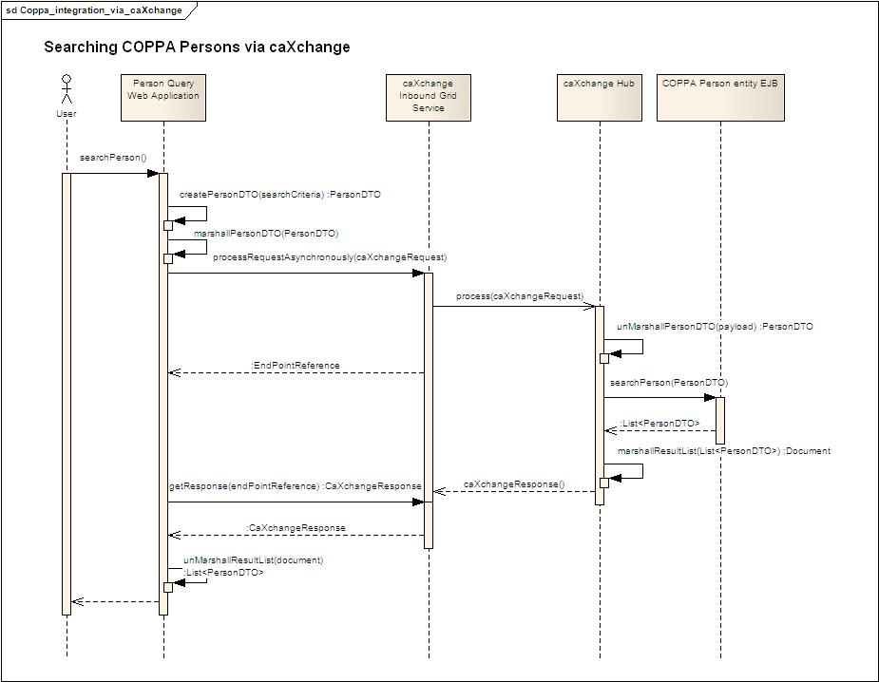
Figure 3 caXchange COPPA ejb interactions.

Serialization – De-Serialization of COPPA data
Integrating caXchange with COPPA ejb services requires serializing and de-serializing COPPA objects to and from XML. The sequence diagram above shows the serialization and de-serialization of COPPA objects in the client and in caXchange. The COPPA model includes an implementation of the ISO 21090 data types; therefore the serialization of the COPPA objects involves serialization and de-serialization of the ISO data types. For the purpose of this prototype we are using the castor framework to perform the default serialization and de-serialization. We had to modify certain COPPA objects to include default constructors. This was required for using the castor framework.
An actual implementation of a serialization mechanism would require an XML binding of the COPPA model. This would ensure that a standard XML serialization/de-serialization mechanism is used by all clients. The xml schema created as part of this binding can then be published using Global Model Exchange. Clients can use the schema to generate valid xml payloads for sending to COPPA service via caXchange. caXchange can use the schema to serialize COPPA objects for returning to clients.

Security
caXchange inbound service is a secured caGrid service. Clients need to have a caGrid proxy to invoke the caXchange inbound service. COPPA ejbs use an instance of the Common Security Module (CSM) to implement their security. For the purpose of the prototype a fixed COPPA user was used for invoking COPPA ejbs.
A potential design for the actual implementation would require a mapping of COPPA users to groups which can be assigned to caXchange users. For example different users can be created for querying COPPA services and for create, update, delete operations. Another way could be different users for different entities Person, Organization so on. These users can then be mapped to caGrid groups created using the caGrid Grouper service. caXchange caGrid users would have permissions to invoke the COPPA ejbs based on their membership to the groups. The table below shows a sample mapping:

COPPA User | caGrid Group Mapped to COPPA User | caXchange User member of caGrid Group.
CCTS_READ_USER | CCTS_GROUP_1 | Grid_user_1
CCTS_UPDATE_USER | CCTS_GROUP_2 | Grid_user_2

Grid user 1 above will invoke COPPA ejbs using the CCTS_READ_USER and will therefore have the privileges of that user for COPPA services.

Steps for actual integration of caXchange to COPPA

Identify COPPA Services to integrate.

Create an XML Binding for the COPPA model and ISO 12090 data types.

Create caXchange servicemix service unit to invoke the required COPPA services.

Define and configure new service types for routing to the caXchange service unit defined in the step above. This may require updating the caXchange interface as noted in Section 4.2.

Define a security mechanism to map caGrid caXchange users to COPPA ejb users. A potential design is noted in Section 4.5.

In addition to these steps an actual integration will need to make sure that COPPA and caXchange servers can talk to each other and the appropriate ports between the two servers are open.

